**SOLANO COMMUNITY COLLEGE**

**MT 162, ROBOTICS**

Fall, 2018

SOLANO COMMUNITY COLLEGE

ROBOTIC SYSTEMS MT-162

**LAB 11: Offsets with Position Registers**

**Catharine Crayne**

11/16/18

**OBJECTIVE**:

1. To learn how to create a motion program that will utilize offsets with position registers.

**GROUP MEMBERS**

*Dianne Halsey, Jerry Livingston, Alex*

**MATERIALS**: RoboGuide and Laptop, Fanuc Robot or RoboGuide

**PROCEDURE**:

1. Power up the robot controller. Place the robot and pendant in Teach Mode.
2. Copy your BOX program and name it OFFSET.
3. Modify the new program so that it uses a data register, initializes it to zero, then performs the box motion, increments the data register, then using an IF conditional check, checks to see if it is greater than 3. If it isn’t, it will repeat the box program. If it is, it will jump out of the loop and return to a home position.
4. Verify the above program works…. Completes the box motion three times and then goes home.
5. Now assign a position register to store the positional offset and manually enter a value of zero on all six elements at the DATA screen.
6. In your program initialize both the counter data register and the offset register (Z).
7. Increment the data register as before, but now also increment the offset register by 15 mm.
8. Have the program loop 5 times, incrementing each time.
9. Verify that it works.

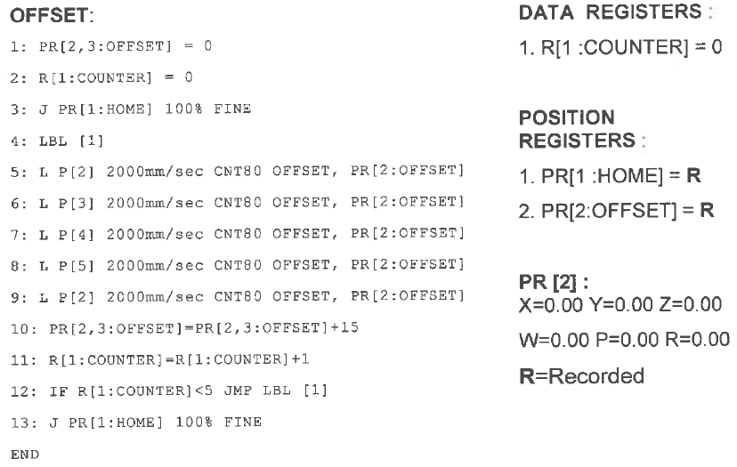

**RESULTS - DATA**

Not Applicable for this lab

**OBSERVATIONS**

Step 2 -9

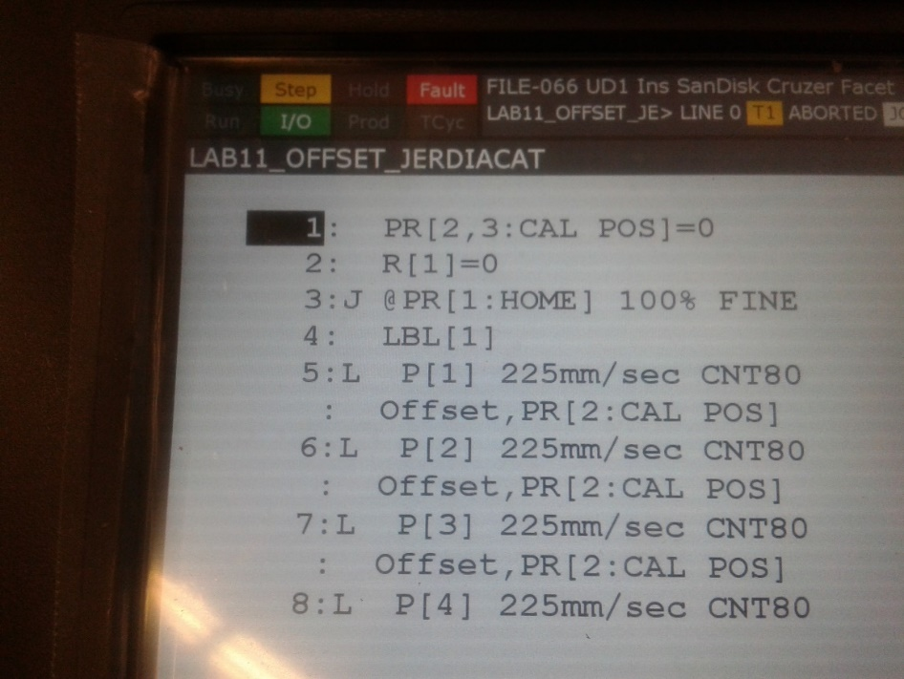

/PROG  LAB11_OFFSET_JERDIACAT

/ATTR

OWNER        = MNEDITOR;

COMMENT        = "";

PROG_SIZE    = 915;

CREATE        = DATE 18-11-13  TIME 20:11:26;

MODIFIED    = DATE 18-11-13  TIME 20:11:26;

FILE_NAME    = LAB7_BOX;

VERSION        = 0;

LINE_COUNT    = 13;

MEMORY_SIZE    = 1367;

PROTECT        = READ_WRITE;

TCD:  STACK_SIZE    = 0,

     TASK_PRIORITY    = 50,

     TIME_SLICE    = 0,

     BUSY_LAMP_OFF    = 0,

     ABORT_REQUEST    = 0,

     PAUSE_REQUEST    = 0;

DEFAULT_GROUP    = 1,*,*,*,*;

CONTROL_CODE    = 00000000 00000000;

/APPL

/MN

  1: PR[2,3]=0    ;

  2: R[1]=0    ;

  3:J PR[1] 100% FINE    ;

  4: LBL[1] ;

  5:L P[1] 225mm/sec CNT80 Offset,PR[2]    ;

  6:L P[2] 225mm/sec CNT80 Offset,PR[2]    ;

  7:L P[3] 225mm/sec CNT80 Offset,PR[2]    ;

  8:L P[4] 225mm/sec CNT80 Offset,PR[2]    ;

  9:L P[5] 225mm/sec CNT80 Offset,PR[2]    ;

 10:  PR[2,3]=PR[2,3]+15    ;

 11:  R[1]=R[1]+1    ;

 12:  IF R[1]<5,JMP LBL[1] ;

 13:J PR[1] 100% FINE    ;

/POS

P[1]{

  GP1:

    UF : 0, UT : 1,        CONFIG : 'N U T, 0, 0, 0',

    X =   493.443  mm,    Y =    59.000 mm,    Z =  -323.196  mm,

    W =  -175.973 deg,    P =      .555 deg,    R =    45.098 deg

};

P[2]{

  GP1:

    UF : 0, UT : 1,        CONFIG : 'N U T, 0, 0, 0',

    X =   364.921  mm,    Y =    59.480 mm,    Z =  -325.716  mm,

    W =  -175.973 deg,    P =      .555 deg,    R =    45.098 deg

};

P[3]{

  GP1:

    UF : 0, UT : 1,        CONFIG : 'N U T, 0, 0, 0',

    X =   364.921  mm,    Y =   -67.480  mm,    Z =  -325.716  mm,

    W =  -175.973 deg,    P =      .555 deg,    R =    45.098 deg

};

P[4]{

  GP1:

    UF : 0, UT : 1,        CONFIG : 'N U T, 0, 0, 0',

    X =   493.322  mm,    Y =   -67.480  mm,    Z =  -325.716  mm,

    W =  -175.973 deg,    P =      .555 deg,    R =    45.098 deg

};

P[5]{

  GP1:

    UF : 0, UT : 1,        CONFIG : 'N U T, 0, 0, 0',

    X =   493.322  mm,    Y =    59.120 mm,    Z =  -325.716  mm,

    W =  -175.973 deg,    P =      .555 deg,    R =    45.098 deg

};

/END

**Analysis Questions:**

1. How would you write a statement that added 15 mm of offset to the X axis of a PR[2]?

*PR[2,1] = PR[2,1]+15*

1. How is using this type of offset advantageous for palletizing and stacking operations?

*Because you will not exceed the reach of the robot.*